Library Management System – Final Report

Cover Page
Group Number: [Enter your Group Number]
Project Title: Library Management System
Group Members:
- Name 1 (email1@example.com)
- Name 2 (email2@example.com)
- Name 3 (email3@example.com)

1. Introduction
This project is a Library Management System designed to manage books, authors, members, and staff. It provides a way to track book loans, returns, and overdue items. The application was built using Microsoft Access, and includes data entry forms, reports, and complex queries to provide comprehensive views for users.

2. Entity Relationship Diagram

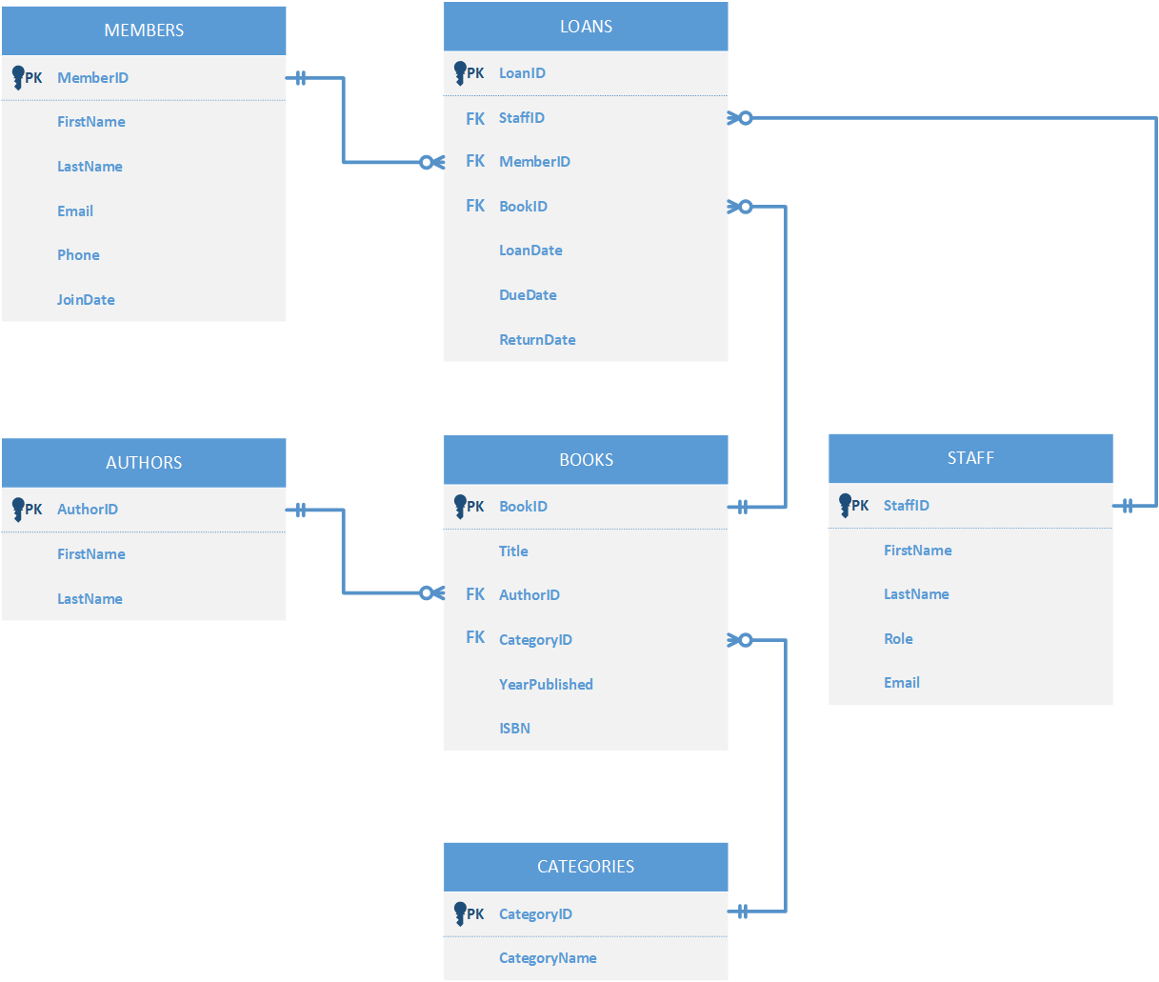
Figure 1. Entity Relationship Diagram

3. Normalized Relations and Functional Dependencies
List of all normalized tables (3NF):
- Authors(AuthorID, FirstName, LastName)
- Categories(CategoryID, CategoryName)
- Books(BookID, Title, AuthorID, CategoryID, YearPublished, ISBN)
- Members(MemberID, FirstName, LastName, Email, Phone, JoinDate)
- Staff(StaffID, FirstName, LastName, Role, Email)
- Loans(LoanID, MemberID, BookID, StaffID, LoanDate, DueDate, ReturnDate)

To ensure the database is well-structured, we applied the normalization process up to the Third Normal Form (3NF). This helped eliminate data redundancy and maintain data integrity across all entities.
To meet 3NF, all attributes are only dependent on the primary key — not on other non-key attributes. For instance:
- Book categories are separated into a Categories table.
- Author details are placed in a separate Authors table and referenced via AuthorID in the Books table.
- Staff information (who processed the loan) is separated into the Staff table.
- The library Members too have a separate table to hold their information.

4. SQL Code
A. CREATE TABLE statements
CREATE TABLE Authors (
AuthorID AUTOINCREMENT PRIMARY KEY,
FirstName TEXT(50),
LastName TEXT(50)
);

CREATE TABLE Categories (
CategoryID AUTOINCREMENT PRIMARY KEY,
CategoryName TEXT(50)
);

CREATE TABLE Books (
BookID AUTOINCREMENT PRIMARY KEY,
Title TEXT(100),
AuthorID LONG,
CategoryID LONG,
YearPublished INT,
ISBN TEXT(20),
FOREIGN KEY (AuthorID) REFERENCES Authors(AuthorID),
FOREIGN KEY (CategoryID) REFERENCES Categories(CategoryID)
);

CREATE TABLE Members (
MemberID AUTOINCREMENT PRIMARY KEY,
FirstName TEXT(50),
LastName TEXT(50),
Email TEXT(100),
Phone TEXT(15),
JoinDate DATE
);

CREATE TABLE Staff (
StaffID AUTOINCREMENT PRIMARY KEY,
FirstName TEXT(50),
LastName TEXT(50),
Role TEXT(50),
Email TEXT(100)
);

CREATE TABLE Loans (
LoanID AUTOINCREMENT PRIMARY KEY,
MemberID LONG,
BookID LONG,
StaffID LONG,
LoanDate DATE,
DueDate DATE,
ReturnDate DATE,
FOREIGN KEY (MemberID) REFERENCES Members(MemberID),
FOREIGN KEY (BookID) REFERENCES Books(BookID),
FOREIGN KEY (StaffID) REFERENCES Staff(StaffID)
);

B. INSERT STATEMENTS
INSERT INTO Authors (FirstName, LastName) VALUES ('George', 'Orwell');
INSERT INTO Authors (FirstName, LastName) VALUES ('Jane', 'Austen');
INSERT INTO Authors (FirstName, LastName) VALUES ('Mark', 'Twain');
INSERT INTO Authors (FirstName, LastName) VALUES ('Harper', 'Lee');

INSERT INTO Categories (CategoryName) VALUES ('Fiction');
INSERT INTO Categories (CategoryName) VALUES ('History');
INSERT INTO Categories (CategoryName) VALUES ('Biography');
INSERT INTO Categories (CategoryName) VALUES ('Science');

INSERT INTO Books (Title, AuthorID, CategoryID, YearPublished, ISBN) VALUES ('1984', 1, 1, 1949, '1234567890');
INSERT INTO Books (Title, AuthorID, CategoryID, YearPublished, 'Pride and Prejudice', 2, 1, 1813, '2345678901');
INSERT INTO Books (Title, AuthorID, CategoryID, YearPublished, ISBN) VALUES ('Adventures of Huckleberry Finn', 3, 1, 1884, '3456789012');
INSERT INTO Books (Title, AuthorID, CategoryID, YearPublished, ISBN) VALUES ('To Kill a Mockingbird', 4, 1, 1960, '4567890123');

INSERT INTO Members (FirstName, LastName, Email, Phone, JoinDate) VALUES ('Alice', 'Smith', 'alice@example.com', '555-1234', #2024-01-15#);
INSERT INTO Members (FirstName, LastName, Email, Phone, JoinDate) VALUES ('Bob', 'Johnson', 'bob@example.com', '555-5678', #2024-02-01#);

INSERT INTO Staff (FirstName, LastName, Role, Email) VALUES ('Laura', 'Jones', 'Librarian', 'laura@example.com');
INSERT INTO Staff (FirstName, LastName, Role, Email) VALUES ('Kevin', 'Brown', 'Assistant', 'kevin@example.com');

INSERT INTO Loans (MemberID, BookID, StaffID, LoanDate, DueDate, ReturnDate) VALUES (1, 1, 1, #2024-04-01#, #2024-04-15#, #2024-04-10#);
INSERT INTO Loans (MemberID, BookID, StaffID, LoanDate, DueDate, ReturnDate) VALUES (2, 2, 2, #2024-04-03#, #2024-04-17#, NULL);
INSERT INTO Loans (MemberID, BookID, StaffID, LoanDate, DueDate, ReturnDate) VALUES (1, 3, 1, #2024-04-05#, #2024-04-19#, #2024-04-20#);
C. QUERIES
SELECT Categories.CategoryName, Books.Title, Books.YearPublished, Books.ISBN, Authors.FirstName, Authors.LastName
FROM Categories INNER JOIN (Authors INNER JOIN Books ON Authors.[AuthorID] = Books.[AuthorID]) ON Categories.[CategoryID] = Books.[CategoryID];

SELECT Books.Title, Books.YearPublished, Books.ISBN, Categories.CategoryName
FROM Books INNER JOIN Categories ON Books.CategoryID = Categories.CategoryID;

SELECT Authors.FirstName, Authors.LastName, Books.Title, Books.YearPublished, Books.ISBN, Categories.CategoryName
FROM Categories INNER JOIN (Authors INNER JOIN Books ON Authors.[AuthorID] = Books.[AuthorID]) ON Categories.[CategoryID] = Books.[CategoryID];

SELECT Members.FirstName & " " & Members.LastName AS MemberName, Books.Title, Books.ISBN, Loans.LoanDate AS BorrowDate, Loans.DueDate, Loans.ReturnDate AS ExpectedReturnDate, Staff.FirstName & " " & Staff.LastName AS ProcessedBy
FROM (((Loans INNER JOIN Books ON Loans.BookID = Books.BookID) INNER JOIN Authors ON Books.AuthorID = Authors.AuthorID) INNER JOIN Members ON Loans.MemberID = Members.MemberID) INNER JOIN Staff ON Loans.StaffID = Staff.StaffID
ORDER BY Loans.LoanDate DESC;

SELECT Members.FirstName, Members.LastName, Count(*) AS TotalLoans
FROM Members INNER JOIN Loans ON Members.MemberID = Loans.MemberID
GROUP BY Members.FirstName, Members.LastName
ORDER BY Count(*) DESC;

SELECT Members.FirstName, Members.LastName, Books.Title, Loans.LoanDate, Loans.DueDate
FROM (Loans INNER JOIN Members ON Loans.MemberID = Members.MemberID) INNER JOIN Books ON Loans.BookID = Books.BookID
WHERE Loans.ReturnDate Is Null And Loans.DueDate < Date();

5. Forms and Reports
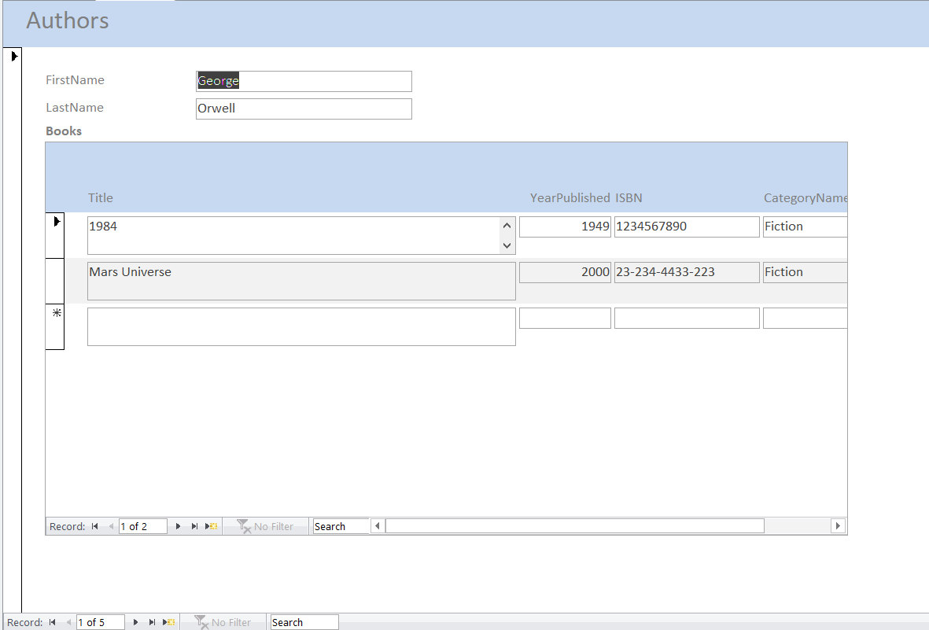
Figure 2. Authors form containing Author’s Firstname and Lastname, and the associated books.
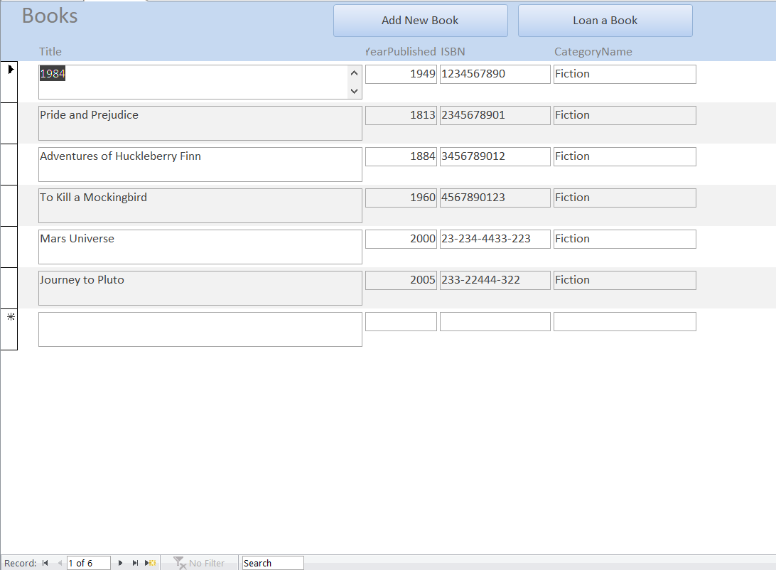
Figure 3. Books form showing book information, and teo Navigation buttons to add a new book, and loan a book.
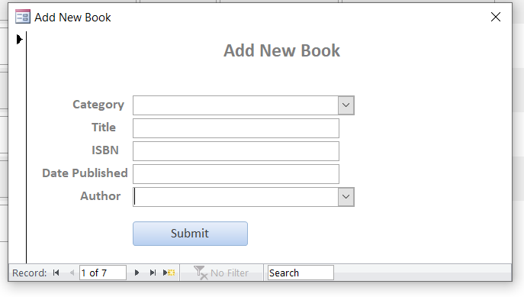
Figure 4. Add New Book form containing dropdowns for Category, and Author while other inputs are textboxes.
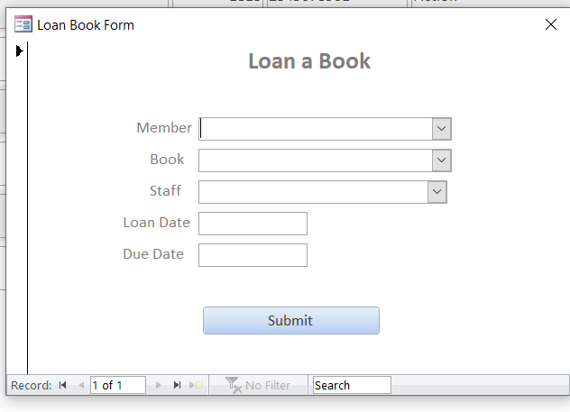
Figure 5. Loan a Book form to loan a book to a member who wants to borrow from the library. Member, Book and Staff are dropdowns that connect to their respective tables. Load date and Due date are textboxes.
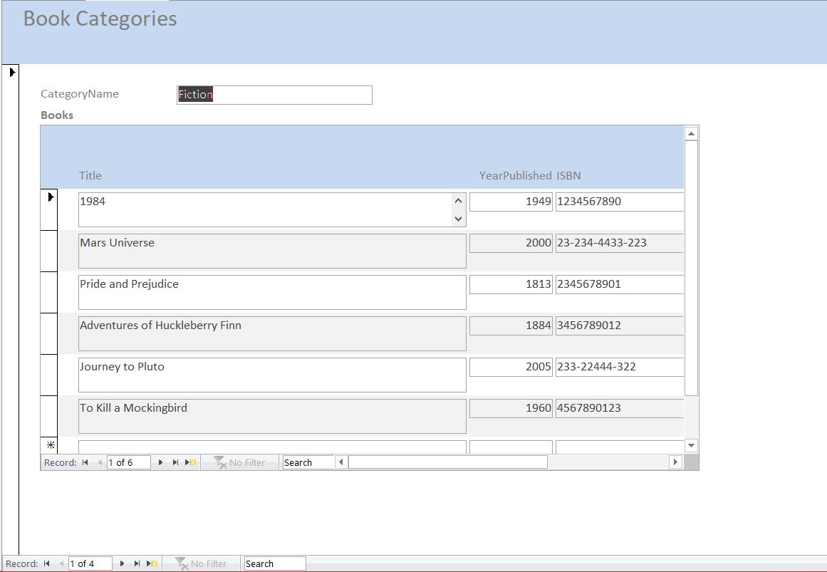
Figure 6. Categories form showing book categories and the books under each category as user move through the record.
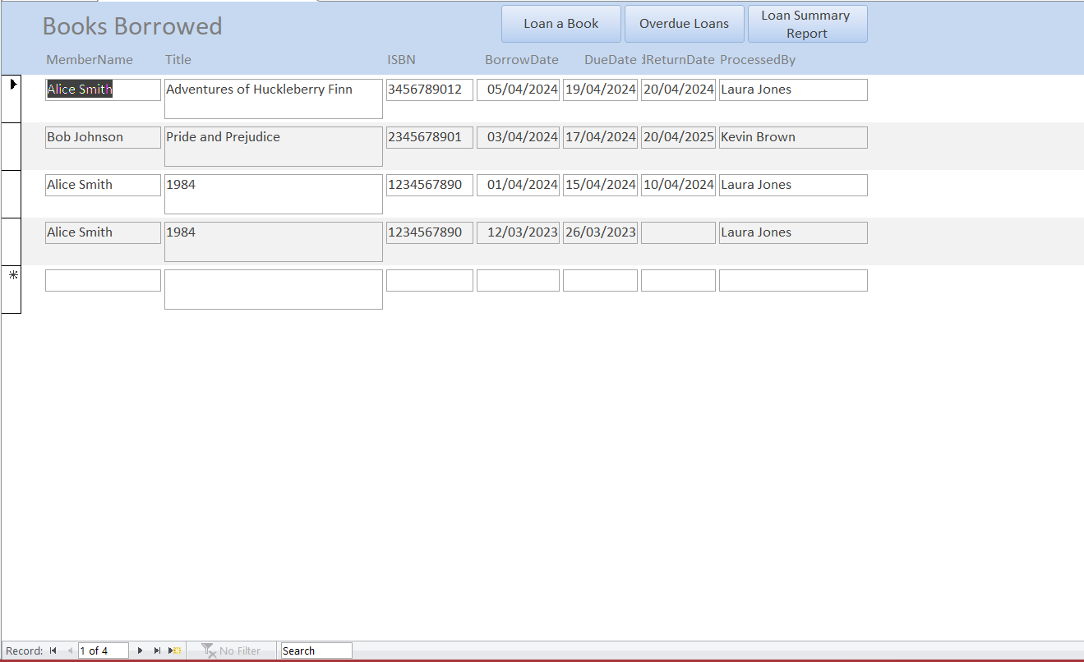
Figure 7. Form showing loaned books. Books borrowed by members are shown here. There are navigation buttons to open form to loan a book, see overdue loans, and loan summary report.
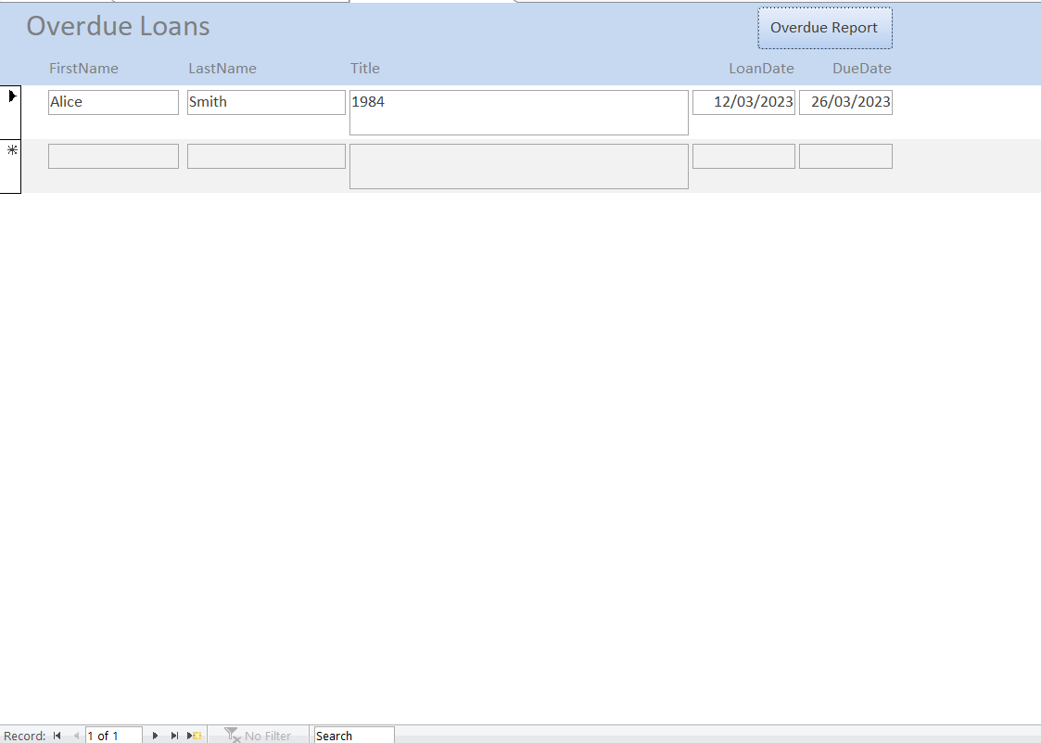
Figure 8. Overdue loans reports that shows books that are overdue for return.
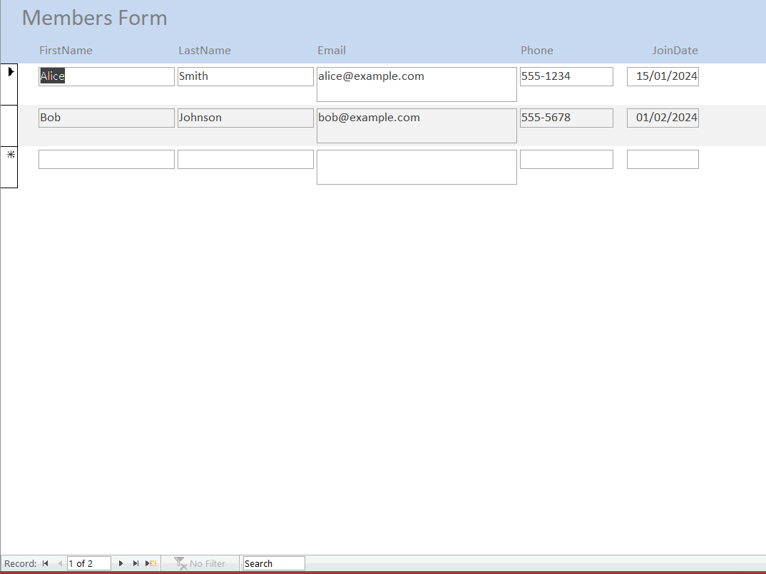
Figure 9. Members form showing member information and entry for new member.
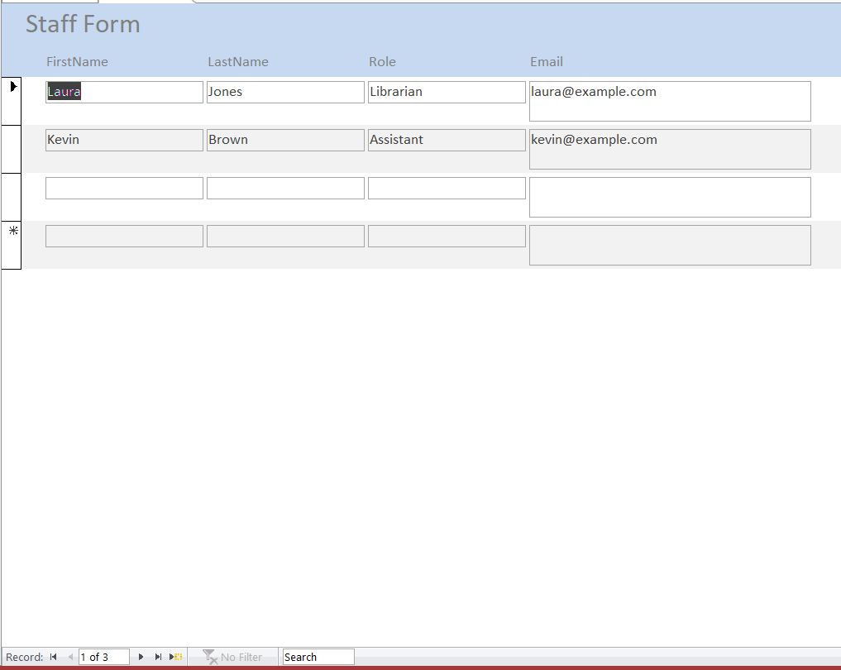
Figure 10. Staff form showing staff information and entry for new staff.

6. Navigation Form

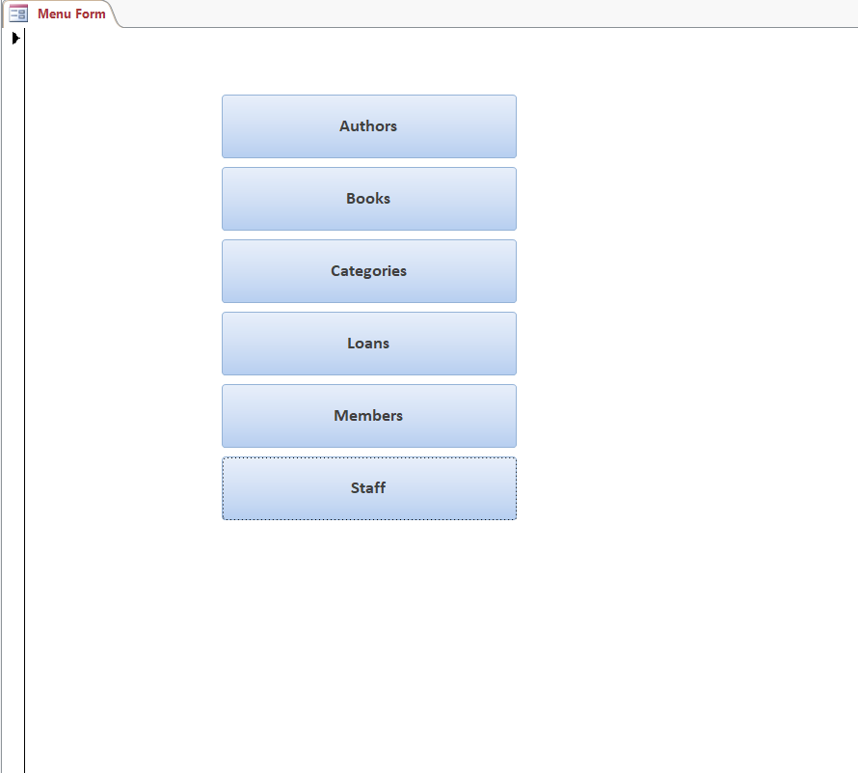
Figure 11. Navigation form
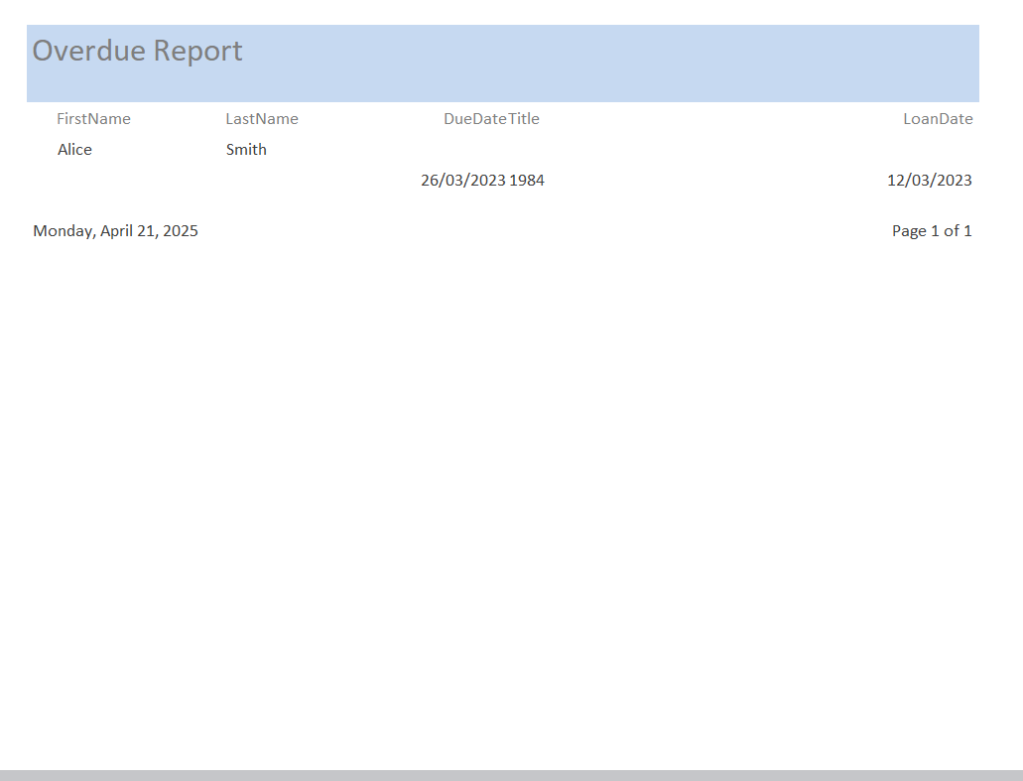
Figure 12. Overdue report
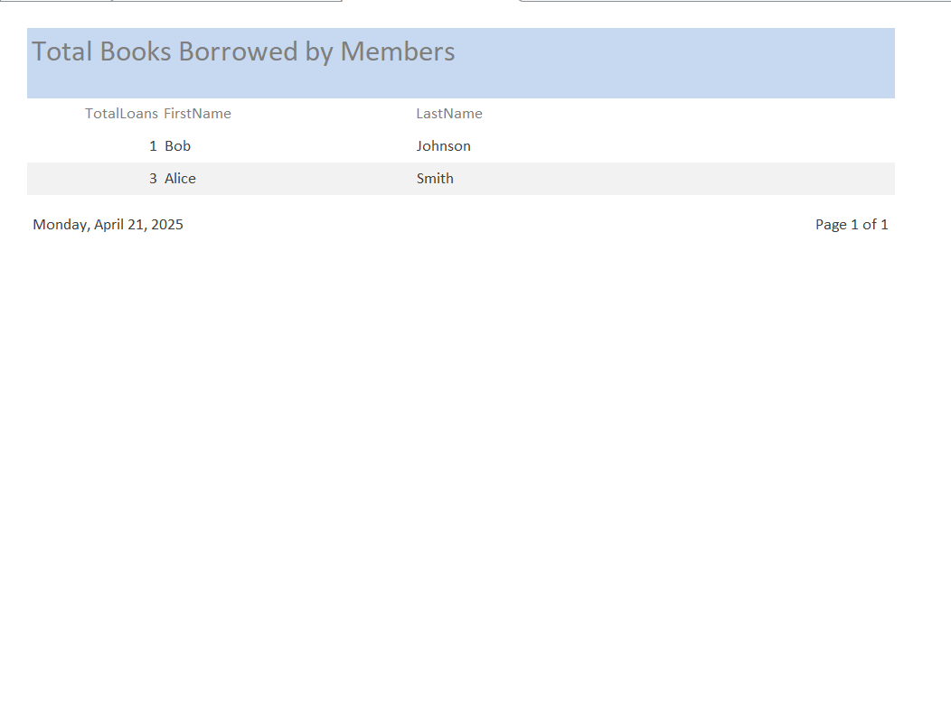
Figure 13. Books load report

7. Conclusion

Through the development of the Library Management System, our group gained valuable hands-on experience in database design, normalization, SQL query writing, and application development using Microsoft Access. We learned how to translate a real-world scenario into a structured database model and how to design functional forms and reports to support business operations. This project also enhanced our understanding of data relationships, referential integrity, and the importance of efficient data entry and retrieval.
Some of the challenges we faced are:
- Designing queries across multiple tables while ensuring performance and clarity was a bit challenging at first.
- Creating well-detailed forms in MS Access with proper linking required some trial and error.
- Ensuring all data was normalized properly without breaking referential integrity took time and careful planning.
We recommend the following for improvements to this application:
- Using a web-based platform for scalability and accessibility across devices.
- Implement user authentication and role-based access control to manage what staff members can view or edit.
- Incorporate features like email reminders for due books, real-time book availability, and advanced analytics for borrowing trends.

8. Peer Evaluation
Here, each member of your group should rate other group members based on their contribution.

